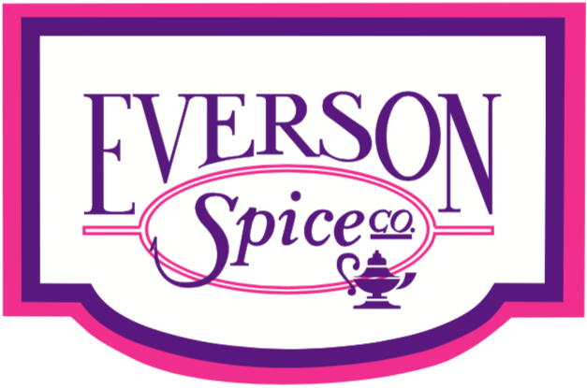

French Fry Sprinkles

300-693 C: Hatch Green Chili Seasoning
T552-041: Beefy Steak Seasoning
101-100 A: Nashville Hot
T551-039: Honey Buffalo
T551-918: Schug [Red]
300-278 K: Fajita Seasoning
T551-202: Chili Margarhita
900-116: Seasoned Lemon Pepper
300-785: Savory Dust
101-127 A: Honey BBQ
300-017 C: Jerk
300-392 A: Greek Sprinkle
300-799 U: Texas Hot & Smokey

Sweet Potato Fry Sprinkles

T551-200: Smokey Honey Habanero
400-299: Mango Habanero
100-105: Sesame Ginger
300-693 C: Hatch Green Chili
T551-323: Korean BBQ
101-100 A: Nashville Hot
T551-039: Honey Buffalo
Spicy Orange Chipotle
300-785: Savory Dust
T550-356: Citrus Verde
101-127 A: Honey BBQ
300-870 U: Lime and Chili
300-017 C: Jerk
300-799 U: Texas Hot & Smokey
101-158: Smokey Hibachi

For additional ideas or work on specific flavor profiles, please contact Chef Cody Masters
CodyM@eversonspice.com or Call: 562-9720814

