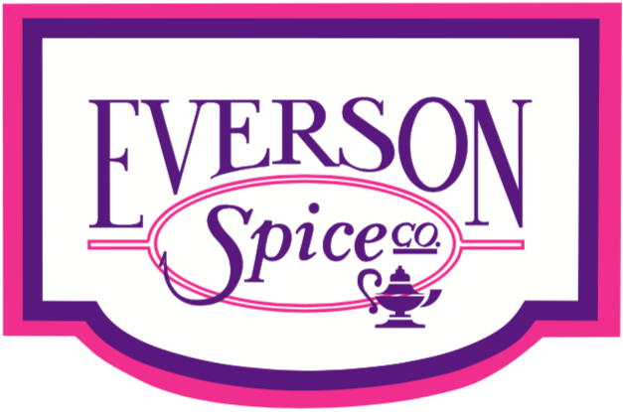

Fried Chicken Sprinkles

Hatch Chili BBQ
Smoked Habanero
Sweet Italian
Tangy Citrus Mango
Fiery Mango
Peppercorn, Lemon & Herb
Zesty Fajita
Hatch Green Chili
Nashville Hot
Buffalo Honey
Hot Honey BBQ
Spicy Orange Chipotle
Smokey Hibachi
Jerk
Texas Hot & Smokey
Sesame Ginger
Savory Dust
Chili Margarita

For additional ideas or work on specific flavor profiles, please contact Chef Cody Masters
CodyM@eversonspice.com or Call: 562-9720814

