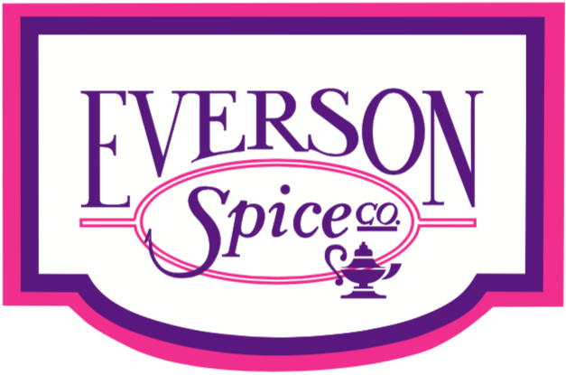

Rotisserie Chicken Sprinkles

"Savory"
Balanced blend of Salt, Pepper, Onion, Garlic, Parsley, Soy Sauce, Paprika

"Fall" / Harvest Blend
Beautiful vegetable particulates and visual. Contains a bit of ginger to showcase seasonal flavor profile

Hatch Green Chili
Bright Hatch Green Chili notes, mild-medium spice level, beautiful particulate size and color

Honey Buffalo
Traditional "Buffalo" flavor profile, slightly sweetened with by the addition of Honey

Fajita
Balanced notes of Chili, Garlic, Onion - but also larger particulate sizes for better visual

Smokey Hibachi
Beautiful visuals, mild Smokey flavor - complimented by notes of traditional Sweet and Spicy
Asian BBQ

Red Mediterranean [Israeli Schug]
On-trend flavor profile of Red Hot Peppers, paired with Garlic, Coriander, Cumin and Fresh Herbs.

Vegetable Pepper Medley
Beautiful visual on vegetable particulates, balanced with simple seasoning of Salt and Pepper

Essence Sprinkle
Balanced blend of Cajun and Blackened seasonings

Peppercorn, Lemon & Herb
Fresh take on traditional Lemon Pepper, using crushed Pink Peppercorns for visual

Seasoned Lemon Pepper
Traditional Lemon Pepper seasoned - slightly boosted by more lively notes of Fresh Lemon

Mango Habanero
Can be made in to a glaze of used as dry rub - apply liberally and enjoy the perfect balance of Sweet and Tart Mango, with Spicy Habanero

Italian Olio
Updated take on traditional Italian seasoning - seasoned and paired with crushed Chili Flakes to drive flavor

BBQ Pepper Medley
Traditional BBQ flavor paired with additional notes of ground Peppercorn

Supreme Pepper Seasoning
Seasoned Peppercorn blend, paired with additions of Mustard, Paprika and Garlic

Honey BBQ Seasoning
Fresh BBQ flavor, slightly sweetened with addition of Honey

Sesame Ginger
High notes of fresh ground Ginger, paired with Sesame, Soy, Garlic and Onion. The more you add the better it will taste

Texas Hot & Smokey Rub
Traditional smokey Texas BBQ, with balanced spice to brighten overall flavor

Blackening Magic
Smokey Blackened flavor profile, paired with Garlic, Onion, Fresh Herbs and spiked with a hint of orange peel

Apple Bourbon Marinade
Can be made in to a glaze or used as a dry rub - this blend drives bright notes of Fresh Apple with balanced flavors of Smokey Bourbon

Spicy Orange Chipotle BBQ
Can be made in to a glaze or used as a dry rub - bright orange flavors, perfectly paired with Smokey Chipotle and traditional BBQ flavors

Lemon Rosemary
Bright citrusy Lemon, paired with beautiful Rosemary particulates, Garlic and Onion

Jerk
Traditional Jerk flavor profile, driving just right amount of sweet, herbaceous heat

Coconut Ginger Garlic
Bold flavors and beautiful visuals of Coconut and Garlic, paired with the aroma of Fresh Ginger

Smokey Hibachi
“Catch All” Asian flavor profile. Smokey notes of soy, sesame and garlic. Beautiful visuals and flavor

Citrus Pepper
New take on Lemon Pepper – contains bright notes of lemon orange, with subtle hints of smoked honey & habanero

Asado Blend
Brighter colors and flavors, then your traditional pollo asado – also contains hints of lemon and green chili

Korean
Traditional notes of onion, garlic and soy – complimented with brown sugar and beautiful vegetable visuals, including crushed gochugaru chili flake

Zesty Lemon & Ginger
Bright notes of lemon and ginger, balanced with savory blend of garlic and onion

For additional ideas or work on specific flavor profiles, please contact Chef Cody Masters
CodyM@eversonspice.com or Call: 562-9720814

